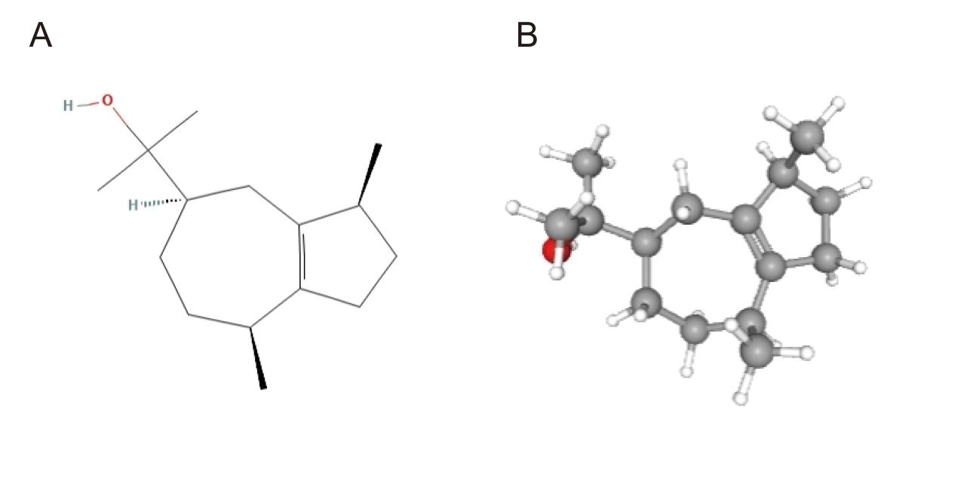
Supplementary Figure S1. A 2D Structure of (-)-Guaiol; B 3D structure of (-)-Guaiol.
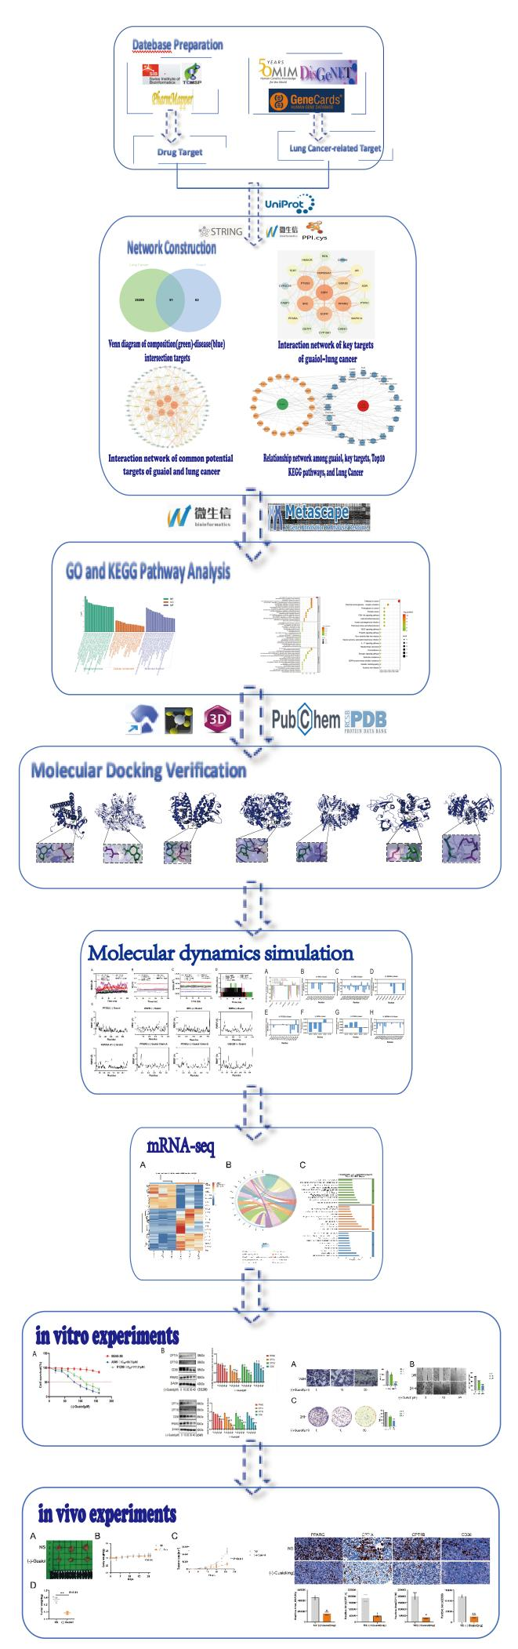
Supplementary Figure S2. Flowchart for Exploring the Molecular Mechanism of Action of (-)-Guaiol for the Treatment of Lung Cancer, Using Network Pharmacology, mRNA Sequencing and Experimental Validation.

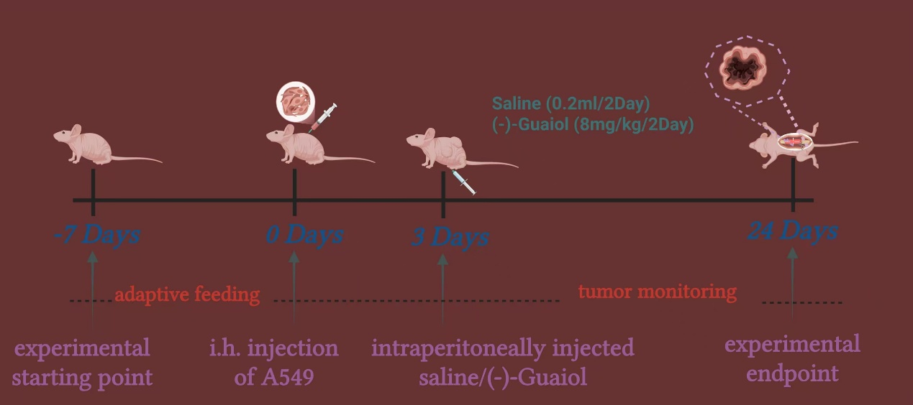
Supplementary Figure S3. Flow chart of animal modeling.

Supplementary Table S1. Gene names of key targets, Degree values, Closeness centrality and Betweenness centrality.
Gene name | Degree value | Closeness centrality | Betweenness centrality
ESR1 | 33 | 0.57419355 | 0.1113184
EGFR | 32 | 0.55974843 | 0.12843102
PPARG | 31 | 0.55625 | 0.07630315
PTGS2 | 29 | 0.58169935 | 0.14750825
HSP90AA1 | 29 | 0.54601227 | 0.10285462
SRC | 25 | 0.54938272 | 0.0913787
GSK3B | 24 | 0.4972067 | 0.04546845
PPARA | 23 | 0.51744186 | 0.03588086
HMGCR | 22 | 0.52662722 | 0.04191891
MAPK14 | 20 | 0.50568182 | 0.03028077
CYP19A1 | 19 | 0.50857143 | 0.03648895
KDR | 18 | 0.50282486 | 0.02297985
AR | 17 | 0.50857143 | 0.01798621
PTPN1 | 15 | 0.47089947 | 0.02350635
REN | 14 | 0.47089947 | 0.03402625
GSTP1 | 13 | 0.47089947 | 0.02314732
TERT | 13 | 0.47340426 | 0.02168369
FABP1 | 13 | 0.45177665 | 0.02335122
CHEK1 | 11 | 0.43414634 | 0.0246155
CYP2C19 | 11 | 0.44278607 | 0.0326167
CHRM2 | 10 | 0.41203704 | 0.03446309

Supplementary Table S2. KEGG pathway annotation with TOP20 enrichment level and the possible targets involved.
KEGG pathways | Enrichment degree | Target count | Targets
Pathways in cancer | 0.428571429 | 9 | AR|EGFR|ESR1|GSK3B|GSTP1|HSP90AA1|PPARG|PTGS2|TERT
Chemical carcinogenesis-receptor activation | 0.285714286 | 6 | AR|EGFR|ESR1|HSP90AA1|PPARA|SRC
Prostate cancer | 0.238095238 | 5 | AR|EGFR|GSK3B|GSTP1|HSP90AA1
Fluid shear stress and atherosclerosis | 0.238095238 | 5 | MAPK14|GSTP1|HSP90AA1|KDR|SRC
Proteoglycans in cancer | 0.238095238 | 4 | MAPK14|KDR|PTGS2|SRC
Lipid and atherosclerosis | 0.238095238 | 4 | MAPK14|ESR1|GSK3B|SRC
Human cytomegalovirus infection | 0.238095238 | 4 | GSK3B|SRC|KDR|EGFR
PI3K-Akt signaling pathway | 0.238095238 | 5 | MAPK14|EGFR|ESR1|KDR|SRC
VEGF signaling pathway | 0.19047619 | 5 | MAPK14|GSK3B|HSP90AA1|PPARG|SRC
Prolactin signaling pathway | 0.19047619 | 5 | MAPK14|EGFR|GSK3B|PTGS2|SRC
EGFR tyrosine kinase inhibitor resistance | 0.19047619 | 4 | MAPK14|GSK3B|HSP90AA1|PTGS2
Endocrine resistance | 0.19047619 | 4 | MAPK14|EGFR|ESR1|SRC
Estrogen signaling pathway | 0.19047619 | 4 | EGFR|ESR1|HSP90AA1|SRC
Alcoholic liver disease | 0.19047619 | 4 | MAPK14|FABP1|GSK3B|PPARA
Non-alcoholic fatty liver disease | 0.19047619 | 4 | MAPK14|GSK3B|PPARA|PPARG
Hepatocellular carcinoma | 0.19047619 | 5 | CHRM2|EGFR|GSK3B|HSP90AA1|KDR
Kaposi sarcoma-associated herpesvirus infection | 0.19047619 | 4 | EGFR|GSK3B|GSTP1|TERT
Focal adhesion | 0.19047619 | 4 | MAPK14|GSK3B|PTGS2|SRC
Diabetic cardiomyopathy | 0.19047619 | 4 | EGFR|GSK3B|KDR|SRC
IL-17 signaling pathway | 0.19047619 | 4 | MAPK14|GSK3B|PPARA|REN

Supplementary Table S3. Binding energies of (-)-Guaiol to various key targets.
Key target | PDBID | Binding energy (kcal/mol)
ESR1 | 3ERT | -7.52
EGFR | 5WB7 | -5.27
PPARG | 6T9C | -7.01
PTGS2 | 5FDQ | -7.38
HSP90AA1 | 7KRJ | -5.73
SRC | 2H8H | -7.61
GSK3B | 4ACH | -7.71

