Supplementary Table S1. Primer sequences used for qRT-PCR.
Gene | Primer | Sequence (5′–3′)
CYP24A1 | Forward | GACCTGATGAGCCTGACGGC
 | Reverse | GAGGGGCTTTGGTATCCGCC
HMGCR | Forward | ACACTTTGGGGAGGCCAACG
 | Reverse | ACATCCACCTCCCGGGTTCA
GDF15 | Forward | TTGTACCAGCCTGAGGGGCT
 | Reverse | ACTGCCCAGGCTGCAATGTT
CDKN1A | Forward | GCGGGTGCGGTGATGGATAA
 | Reverse | GTGGGCGGATTAGGGCTTCC
SPIDR | Forward | GCCGAGACAGGTGGATCACG
 | Reverse | GCACCATCACGCCCGGATAA
GAPDH | Forward | GCGGGGCTCTCCAGAACATC
 | Reverse | TCCACCACTGACACGTTGGC

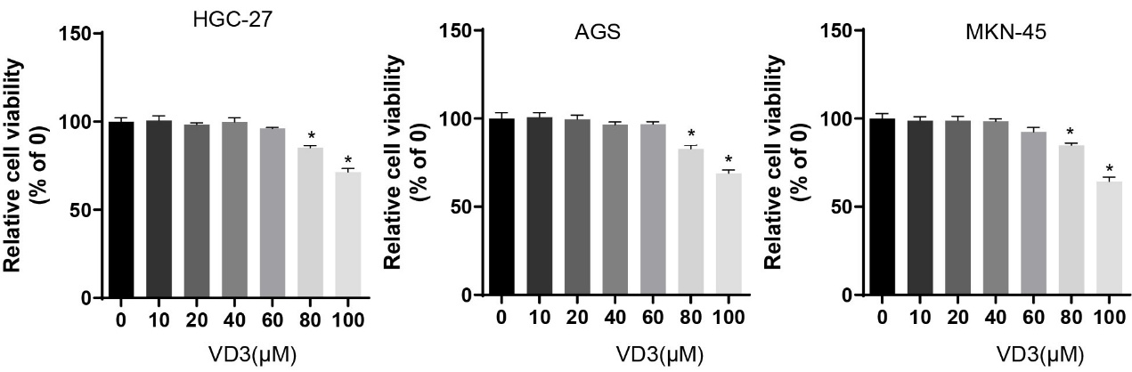
Supplementary Figure S1. Effects of VD₃ on gastric cancer cell viability. HGC-27, AGS, and MKN-45 cells were treated with increasing concentrations of VD₃ (0, 10, 20, 40, 60, 80, and 100 μM) for 24 h, and cell viability was assessed using the CCK-8 assay. Cell viability was normalized to the untreated control group (0 μM). Data are presented as the mean±SD of three independent experiments. Statistical significance was determined by one-way ANOVA. *p < 0.05 vs. the untreated control group

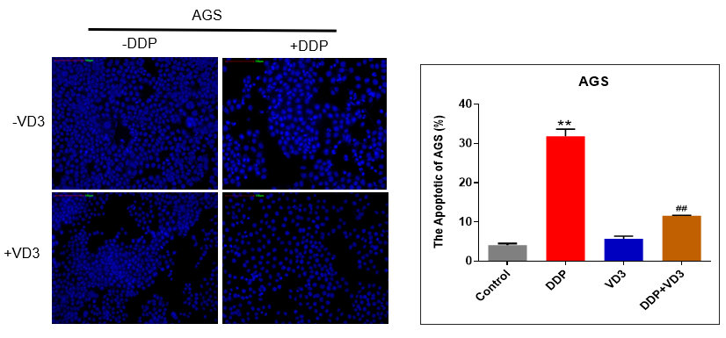
Supplementary Figure S2. Hoechst staining analysis of apoptosis in AGS cells following treatment with DDP and VD₃. AGS cells were treated with vehicle control, VD₃, DDP, or DDP plus VD₃ for 24 h. Apoptosis was assessed by Hoechst staining. Representative fluorescence images and corresponding quantitative analysis are shown. Data are presented as the mean±SD of three independent experiments. Statistical significance was determined by one-way ANOVA. **p < 0.01 vs. the control group; ##p < 0.01 vs. the DDP-treated group

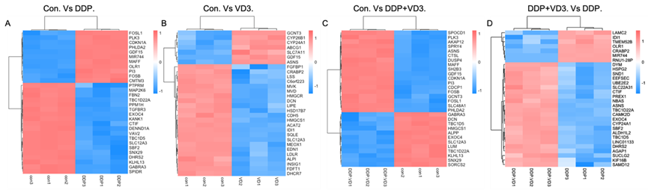
Supplementary Figure S3. Differential gene expression patterns associated with VD₃ and DDP treatment in HGC-27 cells. Heatmaps showing the top 30 differentially expressed genes in the Control vs. DDP (A), Control vs. VD₃ (B), Control vs. DDP plus VD₃ (C), and DDP vs. DDP plus VD₃ (D) comparisons.

Supplementary Figure S4. qRT-PCR validation of representative RNA-seq genes. Relative mRNA expression levels of CYP24A1, HMGCR, GDF15, CDKN1A, and SPIDR were measured in HGC-27 cells following treatment with vehicle control, VD₃, DDP, or DDP plus VD₃ for 24 h. GAPDH was used as the internal control. Relative gene expression was calculated using the 2^{−ΔΔCt} method and normalized to the control group. Data are presented as the mean±SD of three independent experiments. Statistical significance was determined by one-way ANOVA. ***p < 0.001 vs. the control group; ###p < 0.001 vs. the DDP-treated group

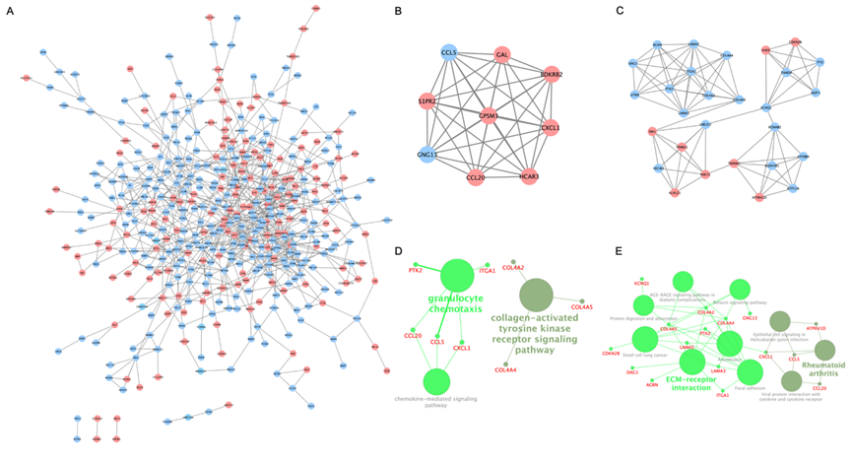
Supplementary Figure S5. Protein–protein interaction network analysis of genes whose DDP-induced expression changes were attenuated by VD₃. A) PPI network constructed using genes that were differentially expressed following DDP treatment but were no longer significantly differentially expressed after co-treatment with VD₃. B-C) Subnetwork analysis of PPI network genes using the MCODE algorithm (selection threshold: MCODE score > 6). D, E) GO and KEGG enrichment analyses of genes within the selected subnetworks.

